CS4375-17800 Fall 2022 Lab Report

<Edgar Garnica > Submitted on <10/12/2022>

<egarnica@miners.utep.edu >

**Lab 2: MLFQ Scheduler for xv6**

Please replace red text with your report text and any tables or figures, names of any accompanying files, etc. Remember to commit all the files for your lab submission, to put the URL for your private xv6 repo in the Teams assignment, to submit the Teams assignment, and to give the instructor, TA, and IA access to your repo.

Task 1. Workload analysis

**Since we are running procs at the same time the round robin will help to set up the time slices to each proc in an equal portion and in circular order, handling the procs without priority**

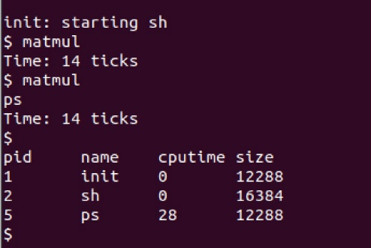Task 2.

**One of the issues at performing the task was how access something that will give the cputime , for that was every time the switch came on or off.**

Task 3.

**For task 3 was time file uses the uptime to calculate the time and the struct of rusage to get the percentage of the CPU at the time of performing something. The output means the total usage of the cpu performing in this case “matmul”**

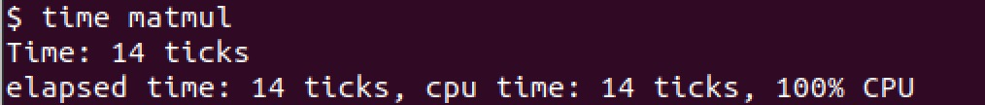

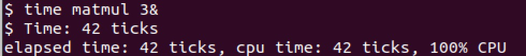

Task 4.

List the files you changed to carry out this task and briefly describe what change syou made to them.

Run some experiments using the RR and MLFQ schedulers with different workloads, and with different values of the time slices for the MLFQ queues. Show and explain your results.

Describe any difficulties you ran into with this task and if/how you overcame them.

**Summary:**

Give an evaluation of how well your MLFQ scheduler worked for different workloads. Suggest possible additional features that might improve its effectiveness.

Describe what you learned from doing this lab.